Question 9:
. Store three laptops with their model numbers. Modify one model number and print the result.
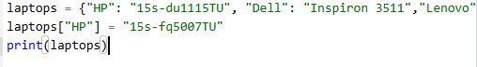
Output:

